WEBSITE DEVELOPMENT PROPOSAL- VEYRA CLOTHING.

ST10481483 |

web Development [wede5020 gr 01]

Lehlogonolo Mokadikwa

2025

**Contents**

**Website Development Proposal – Veyra Clothing Brand** 1

**1. Brief History, Mission, Vision & Target Audience** 1

**2. Website Goals & Objectives** 1

**3. Proposed Features & Functionality** 2

**4. Design & User Experience (UX)** 2

**5. Technical Requirements** 3

**6. Timeline & Milestones** 3

**7. Budget** 4

**8. References** 5

# **Veyra Clothing Brand**

## **1. Brief History, Mission, Vision & Target Audience**

Veyra is a small, independent clothing company that was founded in 2023 and blends classic style, modern streetwear, and minimal luxury. The brand began with social media sales and had since expanded into a fashionable, inclusive brand that sells high-quality clothing for everyday usage.

* Our mission is to provide classic, well-made clothing which combines comfort, style, and innovation to enable people to express their individuality.
* Vision: To become a well-known fashion company with a reputation for streetwise elegance, minimum luxury, and adaptable clothing that goes beyond trends.
* Target Market: Urban, fashion-conscious people between the ages of 18 and 35 who are looking for inclusive, fashionable, and cozy apparel.

## **2. Website Goals & Objectives**

* Showcase Veyra's clothing range with eye-catching images.
* Make it possible to shop online with safe and easy transactions.
* Boost your brand's online visibility and trustworthiness.
* Ensure mobile responsiveness and simple navigation.
* Increase client interaction with newsletters and social media integration.

## **3. Proposed Features & Functionality**

* **Pages**: Contact, FAQs, Lookbook, Shop, About, and Home.
* **E-commerce**: secure checkout, shopping cart, and product catalogue.
* **Responsive design**: Mobile, tablet, and desktop optimization
* **Integration of Social Media**: Links to Facebook, Instagram, and TikTok.
* **SEO & Analytics**: Google Analytics setup and on-page SEO.
* **Security:** SSL encryption, regular backups.

## **4. Design & User Experience (UX)**

**Color Scheme:**

* Off-White (#F5F5F5) – Clean background
* Charcoal (#333333) – Neutral base
* Gold (#D4AF37) – Luxury accent
* Black (#000000) – Timeless, bold

**Typography:**

* **Montserrat** – Modern sans-serif for body text.
* **Playfair Display** – Elegant serif for headings.

**Layout & Design:**

* Consistent visual hierarchy and bold CTAs.
* Full-width hero image/video for impact.
* Grid-based product layout with generous whitespace.

**UX Considerations:**

* Mobile-first responsive design
* Sticky navigation menu.
* High-contrast buttons for accessibility.
* Clear product filters and categories.

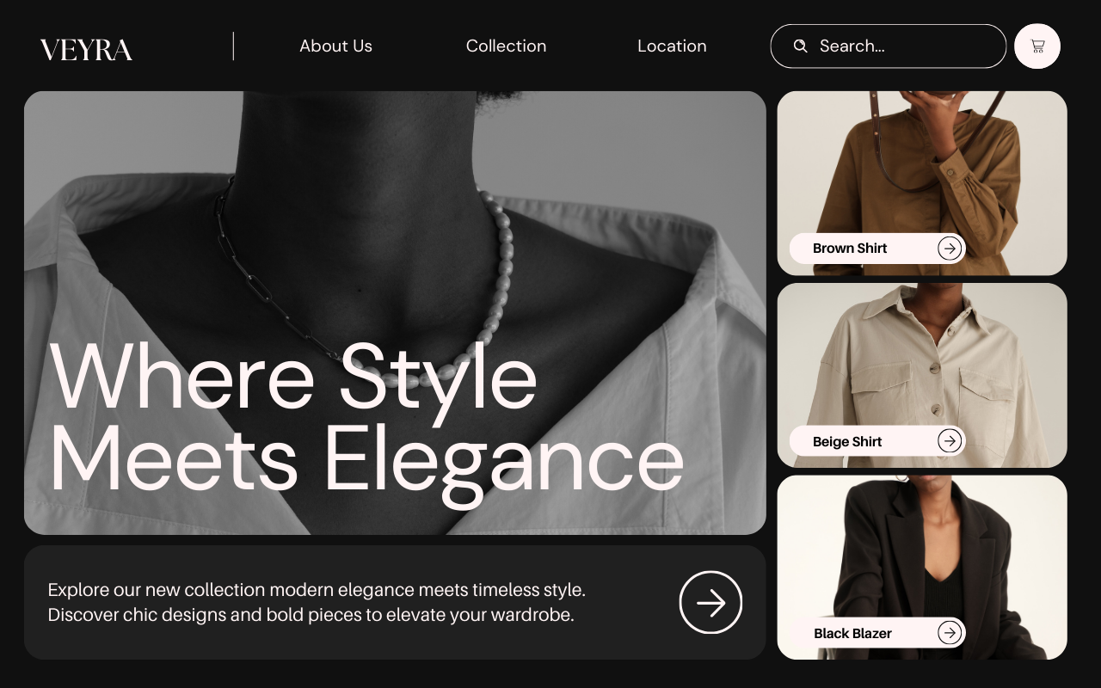

## **5. Technical Requirements**

* Platform: WordPress + WooCommerce or Shopify.
* Languages: HTML5, CSS3, JavaScript.
* Hosting: SSL-enabled, scalable server.
* Security: Regular backups, firewall, malware protection.
* Payment: PayFast, PayPal, Stripe integration.

## **6. Timeline & Milestones**

|  |  |
| --- | --- |
| **Phase** | **Duration** |
| Planning & Research | 1 week |
| Design Mockups | 1 week |
| Development | 2 weeks |
| Testing & Review | 1 week |
| Launch | 1 day |

## **7. Budget**

|  |  |
| --- | --- |
| **Item** | **Cost (ZAR)** |
| Website Design | 4,500 |
| Development & E-commerce | 9,000 |
| Hosting & Domain (1 year) | 1,500 |
| Maintenance (monthly) | 500 |

**Total:** ZAR 15,000

## **8. References**

* Canva, 2025. *Black and White Minimalist Rounded Desktop Prototype.* [Online] Available at: <https://www.canva.com/design/DAGwIfn1DQ8/bTuahq9ge84G5Z3703GXQg/view?mode=prototype>. Accessed [13 August 2025].
* McHoes, A.M. & Flynn, I.M., 2018. *Understanding Operating Systems*, 8th ed. Boston: Cengage Learning.
* Shopify, 2025. *Shopify Help Center*. [Online] Available at: <https://help.shopify.com/>. Accessed [12 August 2025].
* W3C, 2025. *Web Content Accessibility Guidelines (WCAG)*. [Online] Available at: <https://www.w3.org/WAI/>. Accessed [13 August 2025].